**LAB EXERCISE (TEST SUITES)**

**NAME:** Eshan Das**,** Aryaman Mishra

**REGISTRATION NUMBER:** 19BCE1575, 19BCE1027

**TASK 1 (VIRTUAL LAB EXERCISE)**

**SCREENSHOTS**

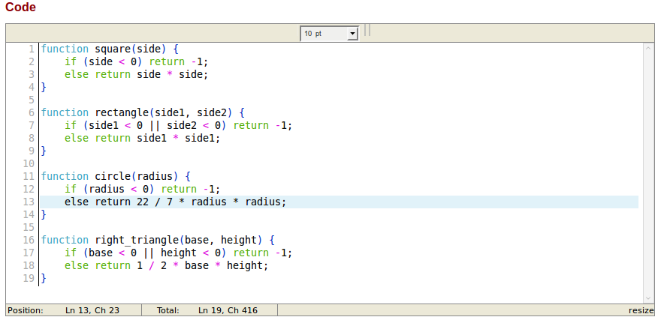

**Results & Discussions**

The code shown above in the text area is the code against which we have to create our test cases. The displayed code is a modified version, which returns -1 whenever any dimension of a shape is specified as negative. Once this code is ready, we can create a test suite and add test cases as shown below.

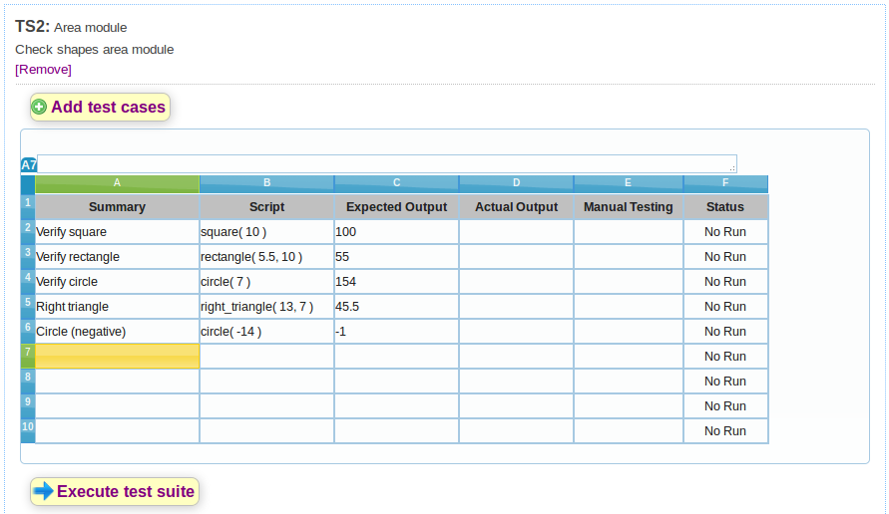

The result of execution of this test suite is displayed below:

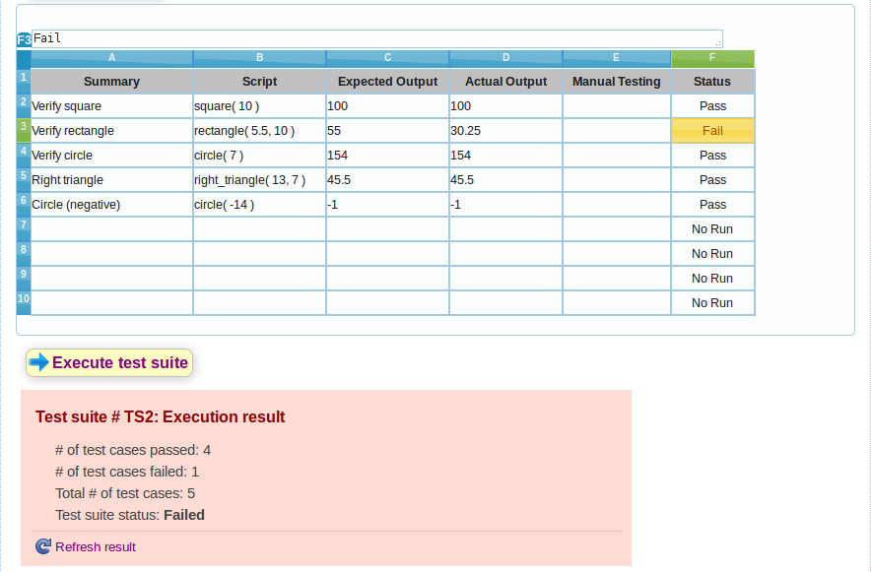

Note that the call to "circle ( -14)" returns -1 as expected. However, one of the test cases, "rectangle (5.5, 10)" fails. We can verify from the "Actual Output" column that this function didn't return the correct value. This is a bug.

To identify the source of this bug, we look at the "rectangle (side1, side2)" function in our code base. After observing carefully, we find that the code in line #8 should have returned "side1 * side2" instead of "side1 * side1". We fix this bug, and run the test suite again. We get the following output where the entire test suite passes.

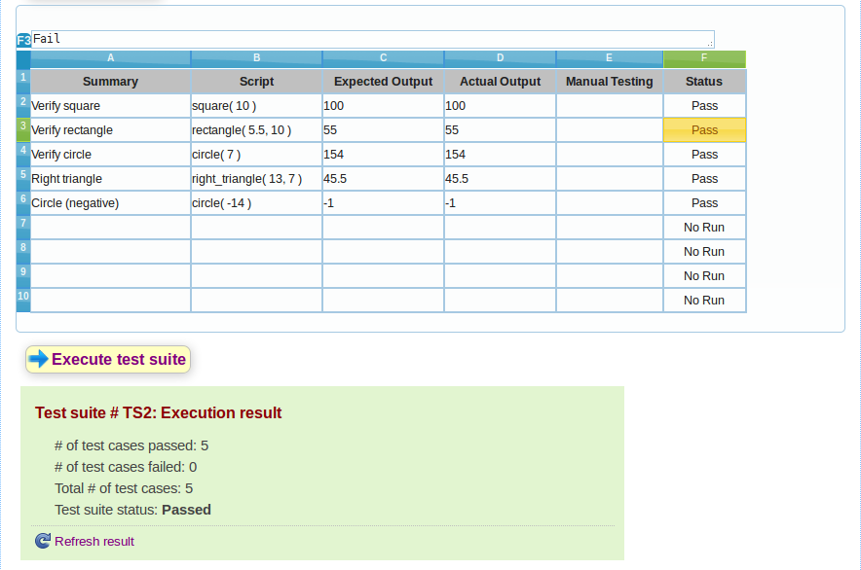

**TASK 2 (Calculator)**

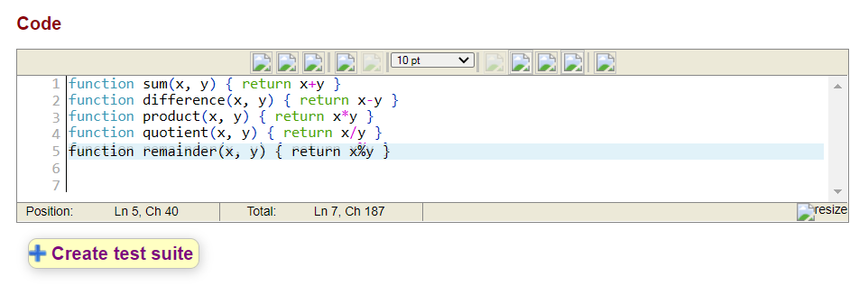

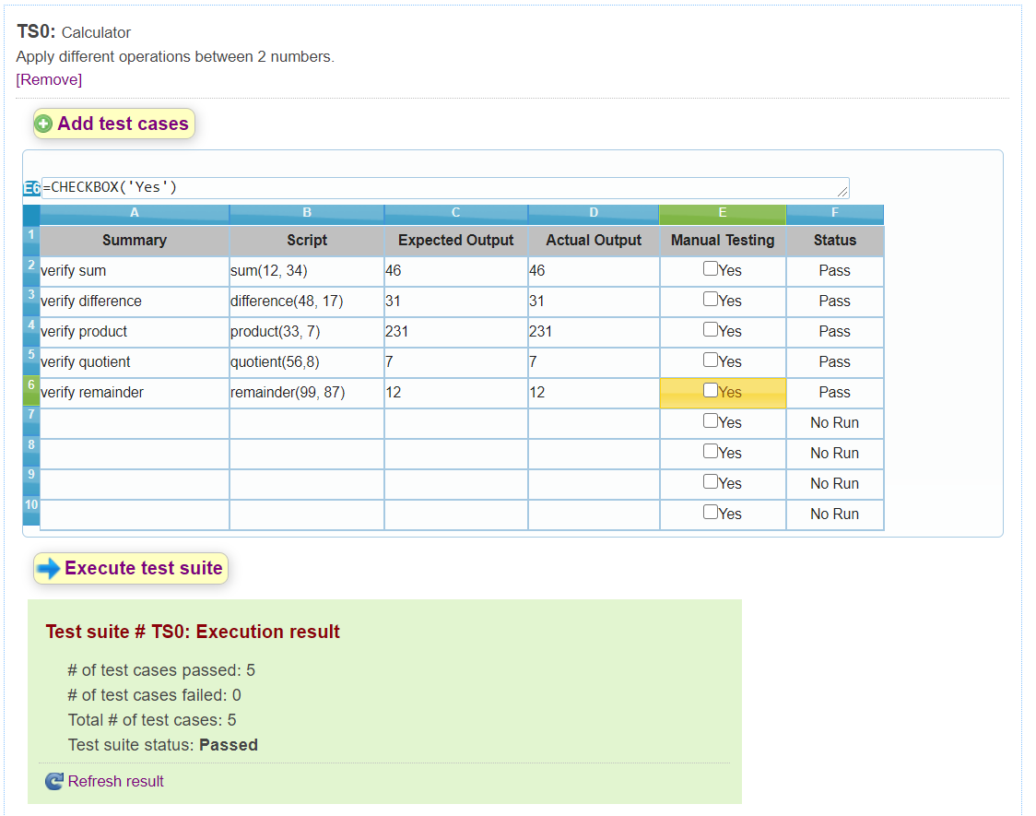

**TASK 3 (Two test suites for the project Login and Signup using J-UNIT)**

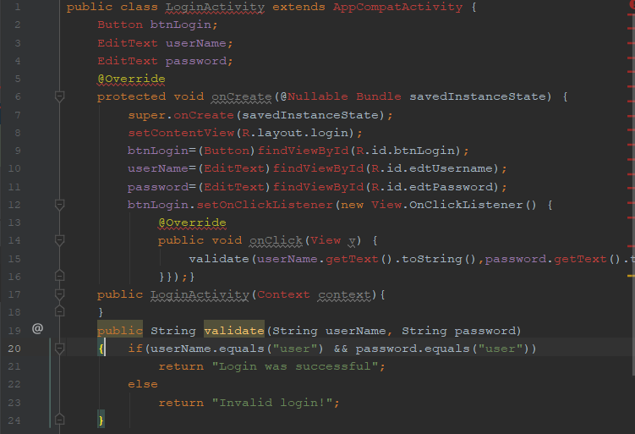

**XML CODE**

<?**xml version="1.0" encoding="utf-8"**?><**android.support.constraint.ConstraintLayout  
xmlns:android="http://schemas.android.com/apk/res/android"  
xmlns:app="http://schemas.android.com/apk/res-auto"  
xmlns:tools="http://schemas.android.com/tools"  
android:layout_width="match_parent"  
android:layout_height="match_parent"**>  
  
<**EditText  
android:id="@+id/edtPassword"  
android:layout_width="0dp"  
android:layout_height="60dp"  
android:layout_marginBottom="50dp"  
android:layout_marginEnd="8dp"  
android:layout_marginStart="8dp"  
android:layout_marginTop="50dp"  
android:ems="10"  
android:hint="Password"  
android:inputType="textPersonName"  
app:layout_constraintBottom_toTopOf="@+id/btnLogin"  
app:layout_constraintEnd_toEndOf="parent"  
app:layout_constraintHorizontal_bias="0.0"  
app:layout_constraintStart_toStartOf="parent"  
app:layout_constraintTop_toBottomOf="@+id/edtUsername"** />  
  
<**EditText  
android:id="@+id/edtUsername"  
android:layout_width="0dp"  
android:layout_height="60dp"  
android:layout_marginEnd="8dp"  
android:layout_marginStart="8dp"  
android:layout_marginTop="47dp"  
android:ems="10"  
android:hint="Username"  
android:inputType="textPassword"  
app:layout_constraintEnd_toEndOf="parent"  
app:layout_constraintStart_toStartOf="parent"  
app:layout_constraintTop_toTopOf="parent"** />  
  
<**Button  
android:id="@+id/btnLogin"  
android:layout_width="0dp"  
android:layout_height="60dp"  
android:layout_marginBottom="360dp"  
android:layout_marginEnd="8dp"  
android:layout_marginStart="8dp"  
android:text="Login"  
android:textColor="@android:color/white"  
android:background="@color/colorPrimaryDark"  
app:layout_constraintBottom_toBottomOf="parent"  
app:layout_constraintEnd_toEndOf="parent"  
app:layout_constraintStart_toStartOf="parent"  
app:layout_constraintTop_toBottomOf="@+id/edtUsername"** />  
</**android.support.constraint.ConstraintLayout**>

